Database management system
IT344

Student Details:
Name: Munirah Alrushud  CRN: 21323 |  | ID: 140032004

Assignment 1
  - Deadline: Day 07/03/2017 @ 23:59
[Total Marks : 4 ]

Question One
2 Marks

A file has r=30,000 EMPLOYEE records of fixed-length.
Consider a disk with block size B=512 bytes. A block pointer is P=6 bytes long and a record pointer is P R =7 bytes long. Each record has the following fields: NAME (30 bytes), SSN (9 bytes), DEPARTMENTCODE (9 bytes), ADDRESS (40 bytes), PHONE (9 bytes), BIRTHDATE (8 bytes), SEX (1 byte), JOBCODE (4 bytes), SALARY (4 bytes, real number). An additional byte is used as a deletion marker.

- Calculate the record size R in bytes.
R = )30 + 9 + 9 + 40 + 9 + 8 + 1 + 4 + 4 +1( +1 = 115 bytes

- Calculate the blocking factor bfr and the number of file blocks b assuming an unspanned organization.
Blocking factor bfr= B ÷ R = 512 ÷ 115 = 4 Records per blocks
Number of file blocks b = r ÷ bfr = 30000 ÷ 4 = 7500 blocks

C. Suppose the file is ordered by the key field SSN and we want to construct a primary index on SSN. Calculate the index blocking factor bfr i.
Index blocking factor bfr i = B ÷ R i
B = 512, R i = ?
Index enter size R i = v _{(ssn)} + P
V_{(ssn)} = 9, PR = 7
Index enter size R i = 9 + 7 =16 bytes
Index blocking factor bfr i = 512 ÷ 16 = 32 entry per blocks.

Question Two
1 Marks
Based on the B+tree in the Figure below, where the maximum capacity of the node is 4 and the minimum is 2. What happens if R is deleted. redraw the results.

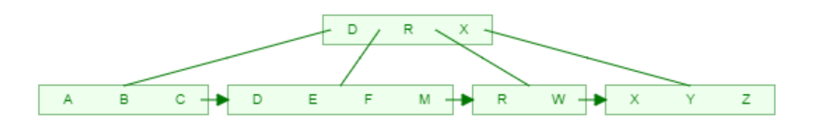

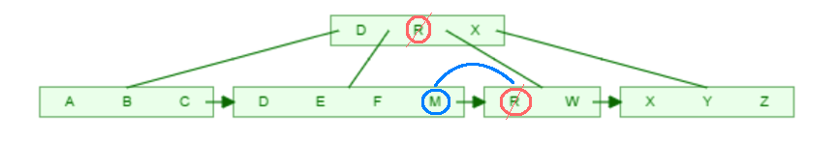

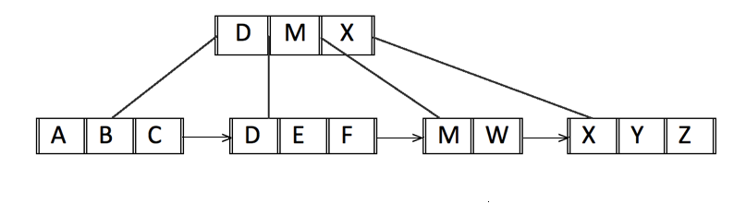

Question Three
1 Marks
Define the term heuristic optimization? Discuss Heuristic optimization of query trees

If we talk about heuristics terminology it’s a group of information determined by the execution plan, and this plan exists to provide the fastest way to execute the queries. So heuristic optimization applying operations that reduce the size of intermediate results.
Overall, if we have data records and queries, there most be an execution plan that will helps to execute the queries much faster with good results.
Query tree is a data structure or tree data structure that represents the queries in leaf nodes of the tree. And represents the relational algebra operations as internal nodes.
In heuristic optimization of query trees there’s more than one way to implement relation algebra expression and in this case it will find the most efficient and the final way for the execution.
Also,, the tree will made a join for some queries and based on this there will be a steps will minimize the number of records.

